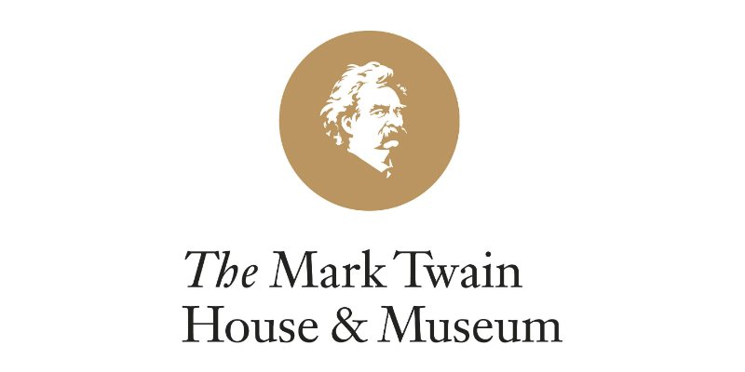 | 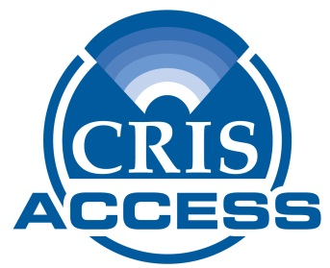

NEWS RELEASE

Contact: Diane Weaver Dunne, CRIS Radio, executive director, 860-527-8000,
dwdunne@crisradio.org
Jennifer LaRue, Director of Marketing and Public Relations, The Mark Twain House & Museum, 860-280-3152, Jennifer.LaRue@Marktwainhouse.org

CRIS Radio and Mark Twain House & Museum Offer
Audible Exhibits for People with Disabilities

Hartford, Conn. –CRIS Radio and The Mark Twain House & Museum are working together to offer visitors with low-vision or other print disabilities a new way to access selected artifacts on exhibit at the museum.

The program, called CRISAccess™, offers on-demand audio versions of print information and audio descriptions of selected exhibits displayed at The Mark Twain House & Museum through a personal smart phone that scans QR (Quick Response) Codes. The QR Codes link the phone to an audio version of an exhibition sign and audio description of the item on display. The recordings typically are less than three minutes long.

National studies report that only 11 percent of people with disabilities visit museums. The collaboration between the two nonprofits provides a low-cost and simple approach to enhance the visitor experience for people with visual or other print disabilities. CRIS Radio based its CRISAccess program on the recommendations of a focus group of people with visual disabilities convened by the Smithsonian.

“We want everyone to know Mark Twain, and so we are thrilled to have support from CRIS Radio in improving access to our exhibition,” said Tracy Brindle, Beatrice Fox Auerbach Chief Curator at The Mark Twain House & Museum. “Because of this initiative, our visitors will be able to better experience original, personal artifacts related to Twain while learning about his life and legacy.”

Paul A. Young, chairman of CRIS Radio’s Board of Directors, echoed Brindle’s enthusiasm for the collaboration. “CRIS Radio is honored to work with staff at The Mark Twain House & Museum to enhance the experience of its visitors who have visual or other print disabilities,” he said. “CRIS continues to expand our services to better fulfill the unmet needs of people with disabilities in the community, providing them with access to the same print information that their friends, family, classmates and colleagues enjoy.”

All CRISAccess recordings feature human narration provided by CRIS Radio volunteers. Funding for this pilot program comes from the Beatrice Fox Auerbach Foundation Fund at the Hartford Foundation for Public Giving, Fund for the Blind of Eastern Connecticut. In addition, support for CRISAccess also comes from the Bissell, Martin and Blackford Foundations.

About CRIS Radio
CRIS Radio (Connecticut Radio Information System) is a 40-year-old nonprofit
based in Windsor and is Connecticut’s only radio-reading service providing audio access 24/7 to news and information for people who are blind or print-challenged, including those unable to read due to physical, learning, intellectual or emotional disabilities. CRIS Radio provides audible exhibits at museums, provides on-demand access to classroom materials, and streams in both English and in Spanish to hospitals and health care facilities. Thanks to more than 200 volunteers, all CRIS recordings feature human narration. For more information, visit www.crisradio.org.
About The Mark Twain House & Museum
The Mark Twain House & Museum is a National Historic Landmark that was the home in which the iconic American author Mark Twain (Samuel Clemens) and his family lived from 1874 to 1891. Twain wrote his most important works during the years he lived there, including Adventures of Huckleberry Finn, The Adventures of Tom Sawyer, and A Connecticut Yankee in King Arthur’s Court. The mission of the Mark Twain House & Museum is to foster an appreciation of the legacy of Mark Twain as one of our nation’s defining cultural figures and to demonstrate the continuing relevance of his work, life, and times. Learn more about The Mark Twain House & Museum at www.marktwainhouse.org.

